History of the Peace Pole Project
A Peace Pole is a monument declaring the message "May Peace Prevail on Earth" in the language of the country in which it is planted and usually several other languages.

The Peace Pole Project was started in Japan by Masahisa Goi (1916 – 1980), who dedicated his life to spreading the message, “May Peace Prevail on Earth”. Mr. Goi was greatly affected by the destruction caused by World War II and the atomic bombs which fell on the cities of Hiroshima and Nagasaki. His desire to assist in the creation of world peace was answered when in 1955, the Peace Message, May Peace Prevail on Earth, came to him in a moment of great inspiration and deep prayer. Not long after Mr. Goi authored the Universal Peace Message in 1955, Peace Poles inscribed with the Peace Message began to appear in various locations across Japan initiating the start of The Peace Pole Project.
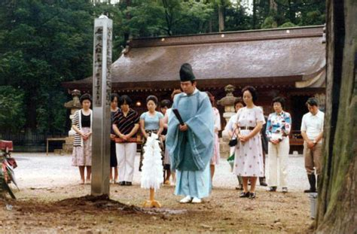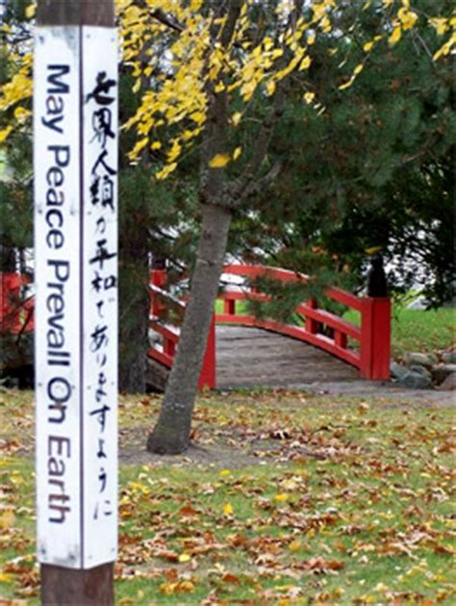

The Peace Pole Project was first introduced to the United States with the opening of The World Peace Prayer Society offices in San Francisco and New York in 1986, The International Year of Peace.
Peace Poles are now the most recognized international peace symbol and monument the world over with more than 200,000 Peace Poles standing in almost every country throughout the world.
Rotary International has adopted Peace and Conflict Resolution as one of its seven areas of focus. Rotarians all over the world are encouraged to promote peace through service projects and community outreach.

Rotary District 5500 has risen to the task and is actively promoting the Peace Pole Project in Southern Arizona. There are a lot of resources available ranging from designing a Peace Pole to planting it. Below are links to a few of the sites clubs can visit to help them with their Peace Pole project.

For further information, please contact our District Peace Committee Chair, Joe Daniszewski at joed57@hotmail.com

